Ideation Phase
Define the Problem Statements

Date | 31 January 2025
Team ID | LTVIP2026TMIDS68930
Project Name | Asset Management Portal
Maximum Marks | 2 Marks

Customer Problem Statement Template:
Create a problem statement to understand your customer's point of view. The Customer Problem Statement template helps you focus on what matters to create experiences people will love.
A well-articulated customer problem statement allows you and your team to find the ideal solution for the challenges your customers face. Throughout the process, you’ll also be able to empathize with your customers, which helps you better understand how they perceive your product or service.
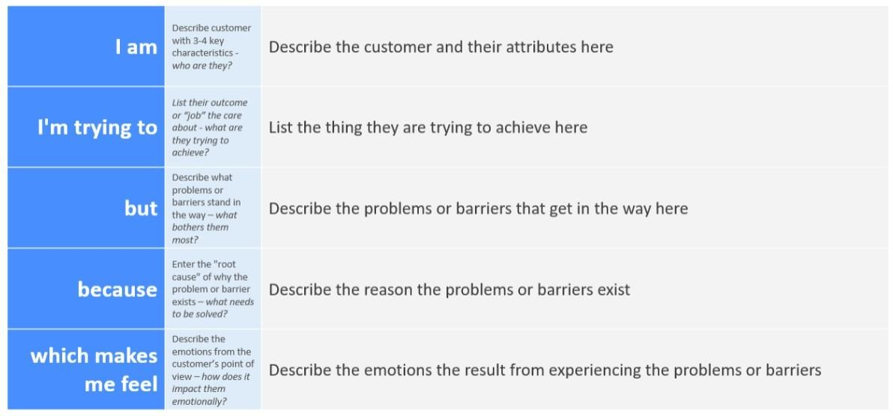
Reference: https://miro.com/templates/customer-problem-statement/ Example:
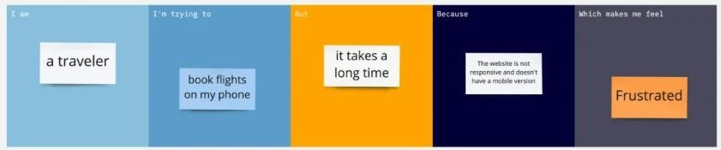

Problem  Statement (PS) | I am  (Customer) | I’m trying to | But | Because | Which makes me feel
PS-1 | A Customer | Book car | It takes  Times | The server is busy | Angry
PS-2 | A owner | Book  Another car | It’s long process | Website loads | Frustrated

